Time Magazine's All-Time 100 Novels
Time Magazine's All-Time best 100 English language Novels from 1923 to 2005.
http://www.time.com/time/2005/100book...
List Challenge
1 | 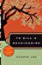 | To Kill a Mockingbird  by Harper Lee
2 | 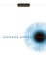 | 1984  by George Orwell
3 | 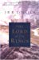 | The Lord of the Rings (The Lord of the Rings, #1-3)  by J.R.R. Tolkien
4 | 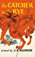 | The Catcher in the Rye  by J.D. Salinger
5 | 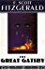 | The Great Gatsby  by F. Scott Fitzgerald
6 | 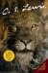 | The Lion, the Witch and the Wardrobe (Chronicles of Narnia, #1) by C.S. Lewis
7 | 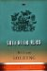 | Lord of the Flies  by William Golding
8 | 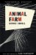 | Animal Farm  by George Orwell
9 |  | Catch-22  by Joseph Heller
10 | 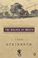 | The Grapes of Wrath  by John Steinbeck
11 | 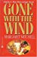 | Gone with the Wind  by Margaret Mitchell
12 | 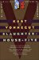 | Slaughterhouse-Five  by Kurt Vonnegut
13 |  | Lolita  by Vladimir Nabokov
14 | 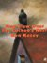 | One Flew Over the Cuckoo's Nest  by Ken Kesey
15 | 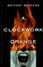 | A Clockwork Orange  by Anthony Burgess
16 | 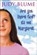 | Are You There God? It's Me, Margaret  by Judy Blume (Goodreads Author)
17 | 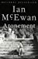 | Atonement  by Ian McEwan
18 | 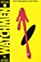 | Watchmen (Watchmen #1-12)  by Alan Moore (Goodreads Author)
19 | 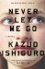 | Never Let Me Go  by Kazuo Ishiguro
20 | 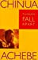 | Things Fall Apart  by Chinua Achebe
21 |  | Invisible Man  by Ralph Ellison
22 | 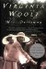 | Mrs. Dalloway  by Virginia Woolf
23 | 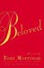 | Beloved  by Toni Morrison
24 |  | On the Road  by Jack Kerouac
25 | 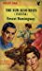 | The Sun Also Rises  by Ernest Hemingway
26 | 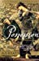 | Possession  by A.S. Byatt
27 | 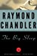 | The Big Sleep (Philip Marlowe, #1)  by Raymond Chandler
28 | 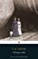 | A Passage to India  by E.M. Forster
29 | 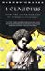 | I, Claudius (Claudius, #1)  by Robert Graves
30 | 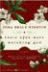 | Their Eyes Were Watching God  by Zora Neale Hurston
31 | 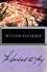 | The Sound and the Fury  by William Faulkner
32 | 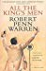 | All the King's Men  by Robert Penn Warren
33 | 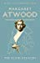 | The Blind Assassin  by Margaret Atwood (Goodreads Author)
34 | 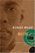 | Native Son  by Richard Wright
35 | 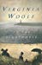 | To the Lighthouse  by Virginia Woolf
36 | 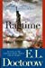 | Ragtime  by E.L. Doctorow
37 | 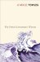 | The French Lieutenant's Woman  by John Fowles
38 | 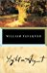 | Light in August  by William Faulkner
39 | 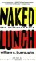 | Naked Lunch  by William S. Burroughs
40 | 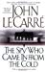 | The Spy Who Came In from the Cold (George Smiley #3)  by John le Carré
41 | 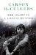 | The Heart Is a Lonely Hunter  by Carson McCullers
42 | 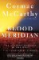 | Blood Meridian, or the Evening Redness in the West  by Cormac McCarthy
43 | 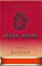 | White Noise  by Don DeLillo
44 | 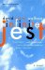 | Infinite Jest  by David Foster Wallace
45 | 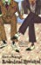 | Brideshead Revisited: The Sacred and Profane Memories of Captain Charles Ryder  by Evelyn Waugh  Rea
46 | 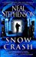 | Snow Crash  by Neal Stephenson (Goodreads Author)
47 | 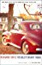 | Revolutionary Road  by Richard Yates
48 | 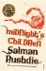 | Midnight's Children  by Salman Rushdie
49 | 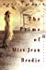 | The Prime of Miss Jean Brodie  by Muriel Spark
50 | 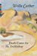 | Death Comes for the Archbishop  by Willa Cather
51 | 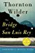 | The Bridge of San Luis Rey  by Thornton Wilder
52 | 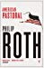 | American Pastoral (The American Trilogy, #1)  by Philip Roth
53 | 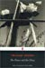 | The Power and the Glory  by Graham Greene
54 | 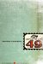 | The Crying of Lot 49  by Thomas Pynchon
55 | 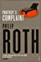 | Portnoy's Complaint  by Philip Roth
56 |  | Wide Sargasso Sea  by Jean Rhys
57 | 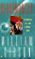 | Neuromancer (Sprawl, #1)  by William Gibson
58 | 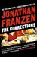 | The Corrections  by Jonathan Franzen
59 | 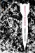 | Gravity's Rainbow  by Thomas Pynchon
60 | 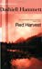 | Red Harvest  by Dashiell Hammett
61 |  | White Teeth  by Zadie Smith
62 | 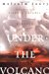 | Under the Volcano  by Malcolm Lowry
63 | 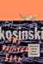 | The Painted Bird  by Jerzy Kosiński
64 | 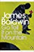 | Go Tell It on the Mountain  by James Baldwin
65 | 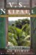 | A House for Mr Biswas  by V.S. Naipaul
66 | 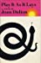 | Play It as It Lays  by Joan Didion
67 | 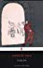 | Lucky Jim  by Kingsley Amis
68 | 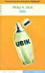 | Ubik  by Philip K. Dick
69 | 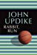 | Rabbit, Run (Rabbit Angstrom #1)  by John Updike
70 | 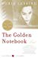 | The Golden Notebook  by Doris Lessing
71 | 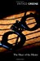 | The Heart of the Matter  by Graham Greene
72 | 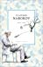 | Pale Fire  by Vladimir Nabokov
73 | 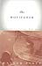 | The Moviegoer  by Walker Percy
74 | 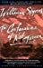 | The Confessions of Nat Turner  by William Styron
75 | 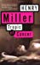 | Tropic of Cancer  by Henry Miller
76 | 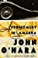 | Appointment in Samarra  by John O'Hara
77 | 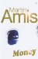 | Money  by Martin Amis
78 | 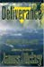 | Deliverance  by James Dickey
79 | 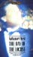 | The Day of the Locust  by Nathanael West
80 | 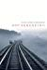 | Housekeeping  by Marilynne Robinson
81 | 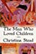 | The Man Who Loved Children  by Christina Stead
82 | 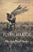 | The Sot-Weed Factor  by John Barth
83 | 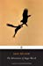 | The Adventures of Augie March  by Saul Bellow
83 | 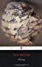 | Herzog  by Saul Bellow
85 | 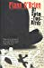 | At Swim-Two-Birds  by Flann O'Brien
86 | 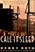 | Call It Sleep  by Henry Roth
87 | 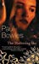 | The Sheltering Sky  by Paul Bowles
88 | 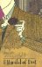 | A Handful of Dust  by Evelyn Waugh
89 | 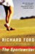 | The Sportswriter  by Richard Ford
90 | 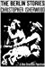 | The Berlin Stories: The Last of Mr Norris/Goodbye to Berlin  by Christopher Isherwood
91 | 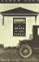 | A Death in the Family  by James Agee
92 | 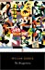 | The Recognitions  by William Gaddis
93 | 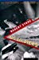 | Dog Soldiers  by Robert Stone
94 | 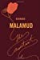 | The Assistant  by Bernard Malamud
95 | 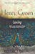 | Loving  by Henry Green
96 | 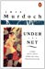 | Under the Net  by Iris Murdoch
97 | 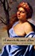 | A Dance to the Music of Time: 1st Movement (A Dance to the Music of Time, #1-3)  by Anthony Powell
98 | 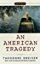 | An American Tragedy  by Theodore Dreiser
99 | 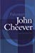 | Falconer  by John Cheever
100 | 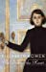 | The Death of the Heart  by Elizabeth Bowen

https://www.goodreads.com/list/show/2681.Time_Magazine_s_All_Time_100_Novels

